1) Create on Bash script to check if a directory is available or not.

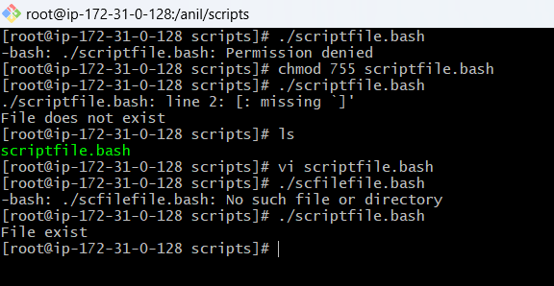

2) Create a bash script which will create multiple files.

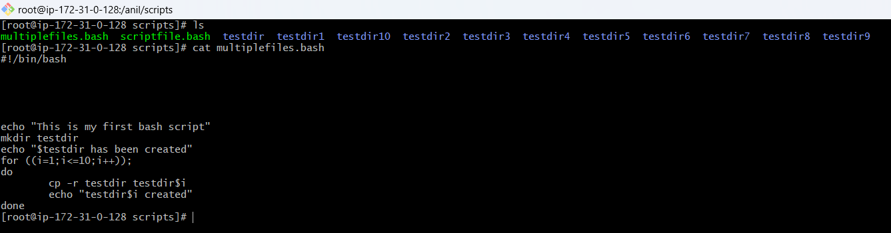

3) Create a bash script to install nginx in ec2 server.

**Connect to your EC2 instance** via SSH:

**Create a new script file**:

**Run the script**:

Make sure your security group settings for the EC2 instance allow inbound traffic on ports 80 (HTTP) and 443 (HTTPS).

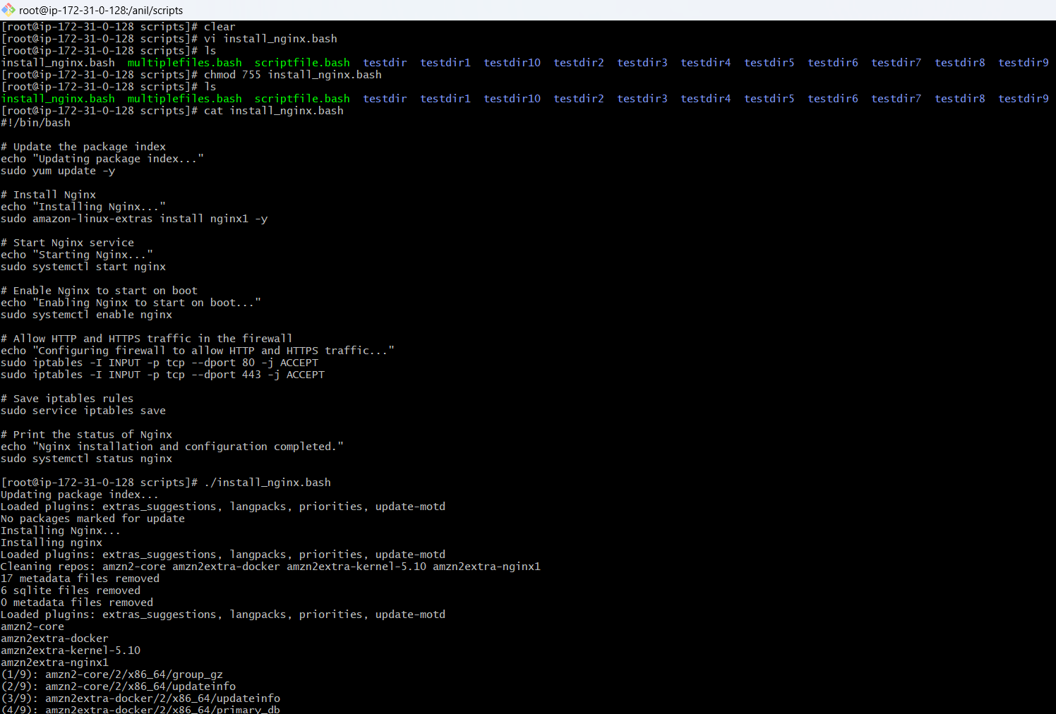

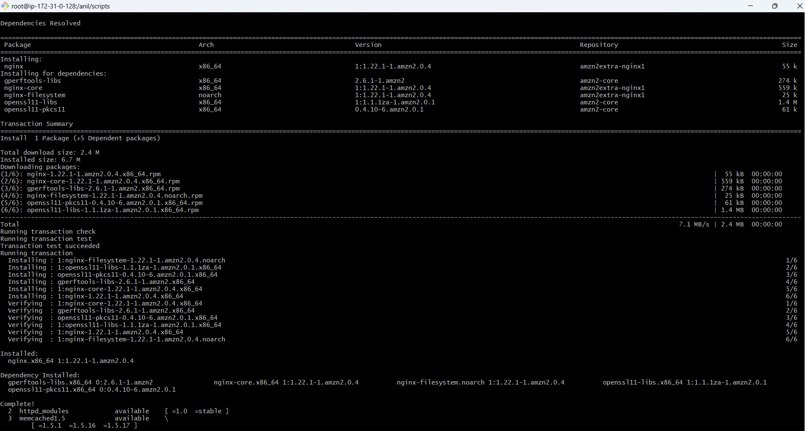

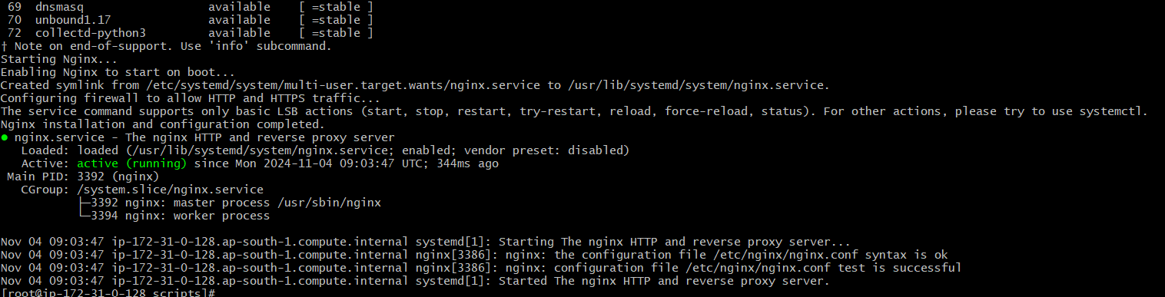

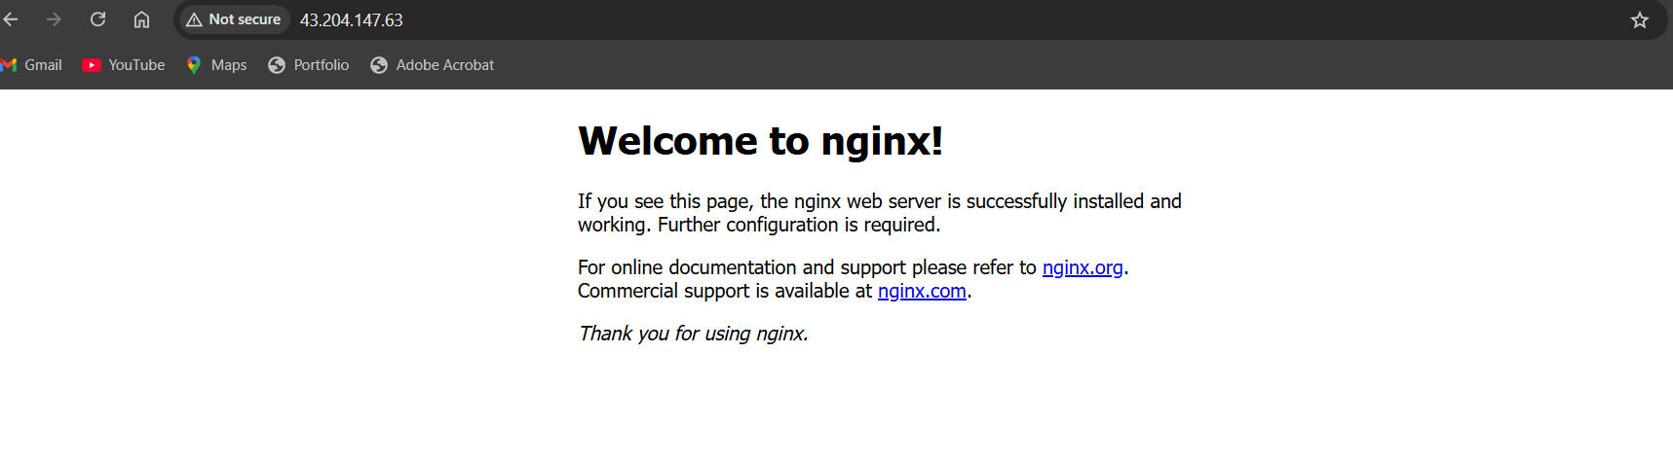

4) Create a bash script to install ApacheTomcat in ec2 server.

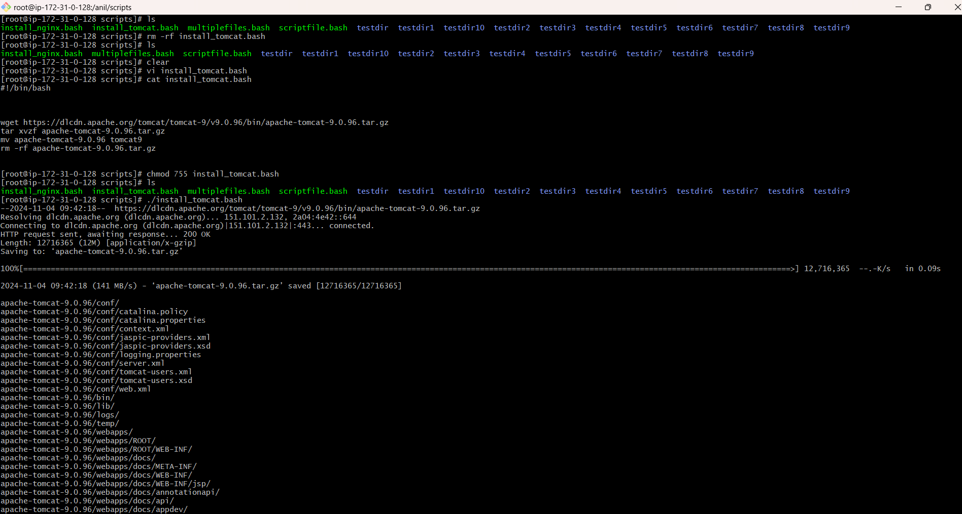

5) Create a bash script to check list if nginx service is running or not,if not running then script should start the service.

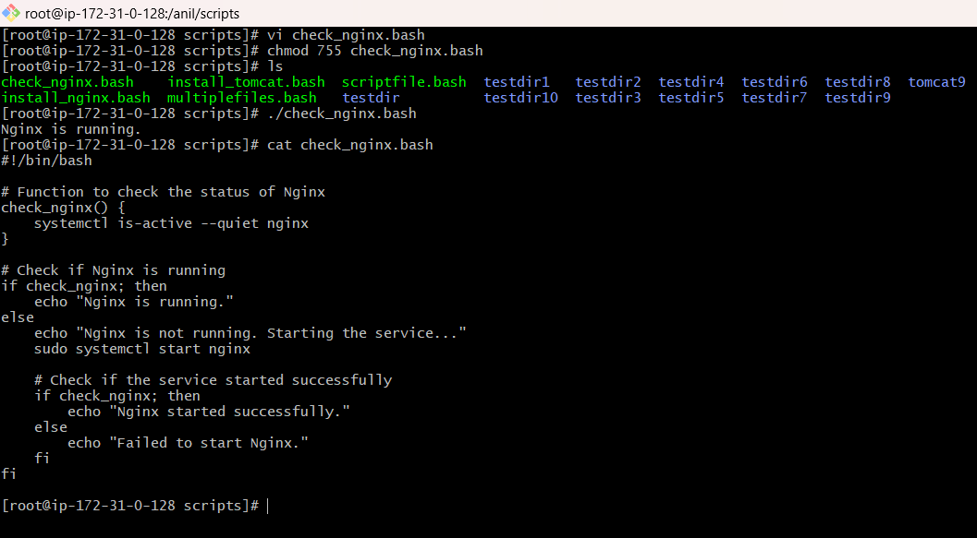

6 ) Create a bash script for calculator.  
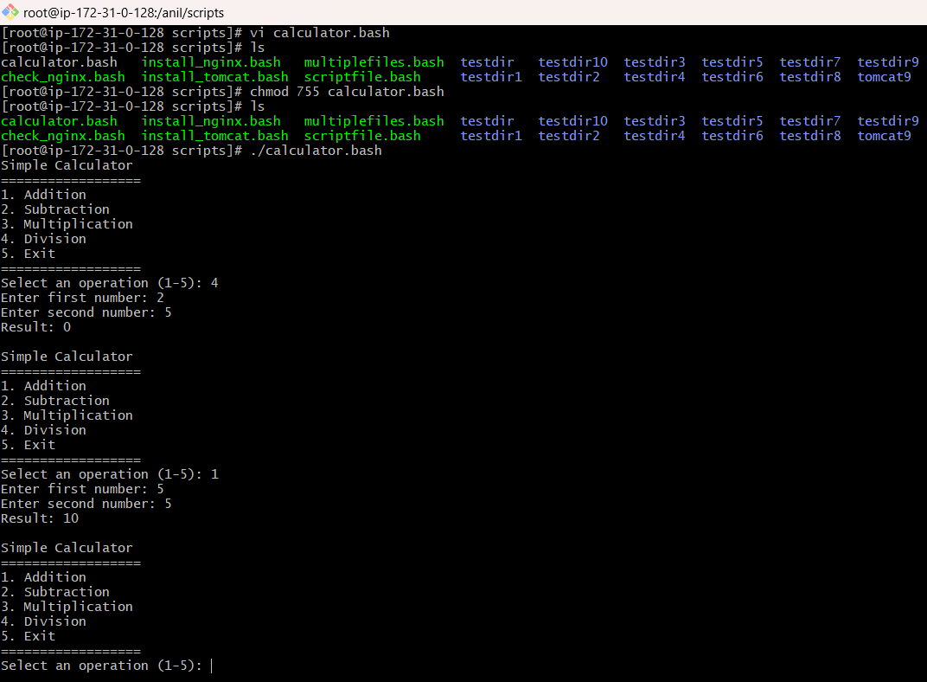

7) Create a bash script to check if directory is avaialble or not,if not then create a directory.

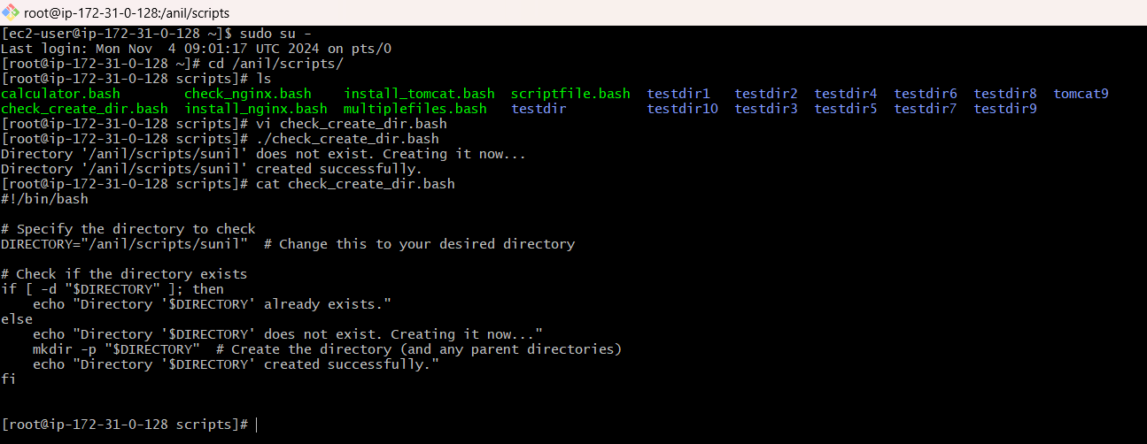

8) Create a bash script to take backup of a directory.

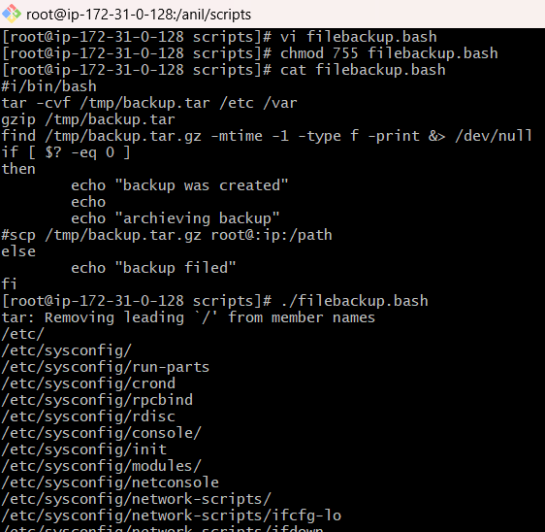

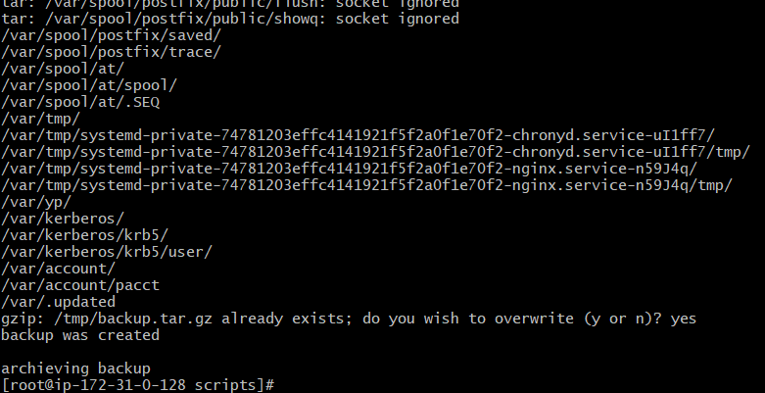

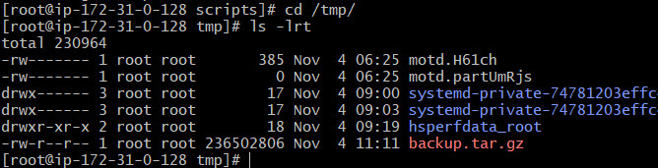

9) Exercise Crontab Entries :

**Crontab** is a Unix/Linux utility that allows users to schedule jobs (commands or scripts) to run automatically at specified intervals or times. The name "crontab" comes from "cron," which is the daemon that executes scheduled commands, and "tab," referring to the table format in which the jobs are stored.

**Key Features of Crontab**

1. **Scheduling**: Crontab allows you to specify exactly when a command should run—every minute, hour, day, week, or month, or at specific times.
2. **Syntax**: Each crontab entry consists of five fields followed by the command to be executed. The fields represent:
   * Minute (0-59)
   * Hour (0-23)
   * Day of the Month (1-31)
   * Month (1-12)
   * Day of the Week (0-7, where both 0 and 7 represent Sunday)

a) April 5th Midnight

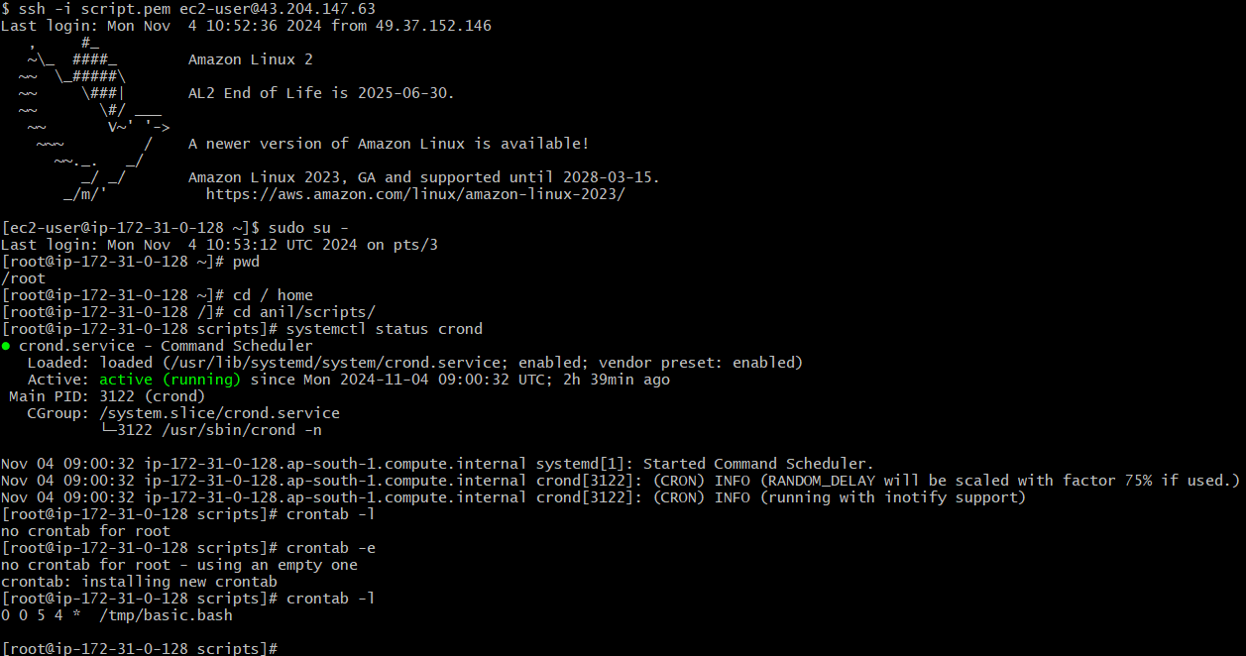

a) April 5th Midnight:

== >0 0 5 4 *

b) **5th of Every November, January, June if it is a Thursday:**

== > 0 0 5 11,1,6 * [ "$(date +\%u)" -eq 4 ]

== > date +\%u: The date command with +%u returns the day of the week as a number (1 for Monday, 2 for Tuesday, ..., 7 for Sunday, with 0 also representing Sunday on some systems). Here, 4 represents Thursday.

C) At 05 and 27th minutes of 9, 10, 11 hours every day

== > 5,27 9-11 * * *

d) 34 minutes of the 9th hour on 15th August

== > 34 9 15 8 *

e) Every Weekend (Saturday night 11:59)

== > 59 23 * * 6

f) After every reboot

== > @reboot /usr/bin/systemctl start your-service